Titan Shop Spaces:

Plant 4 Shop Space (Machine Shop) {110ft long by 22ft wide and 25x 35ft)

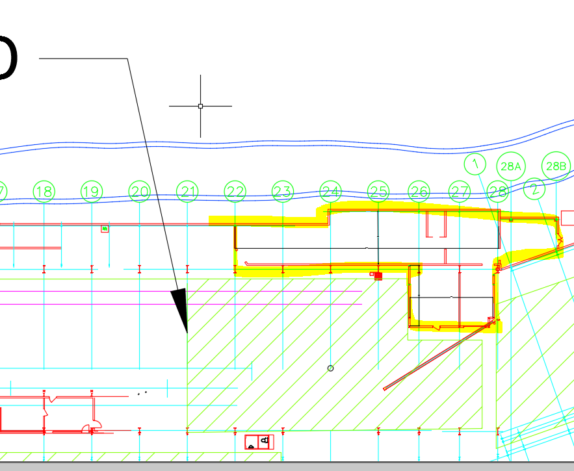

Plant 4 Shop Areas 1 (27ft x 60ft) & Area 2 (12ft x 38.5 ft)
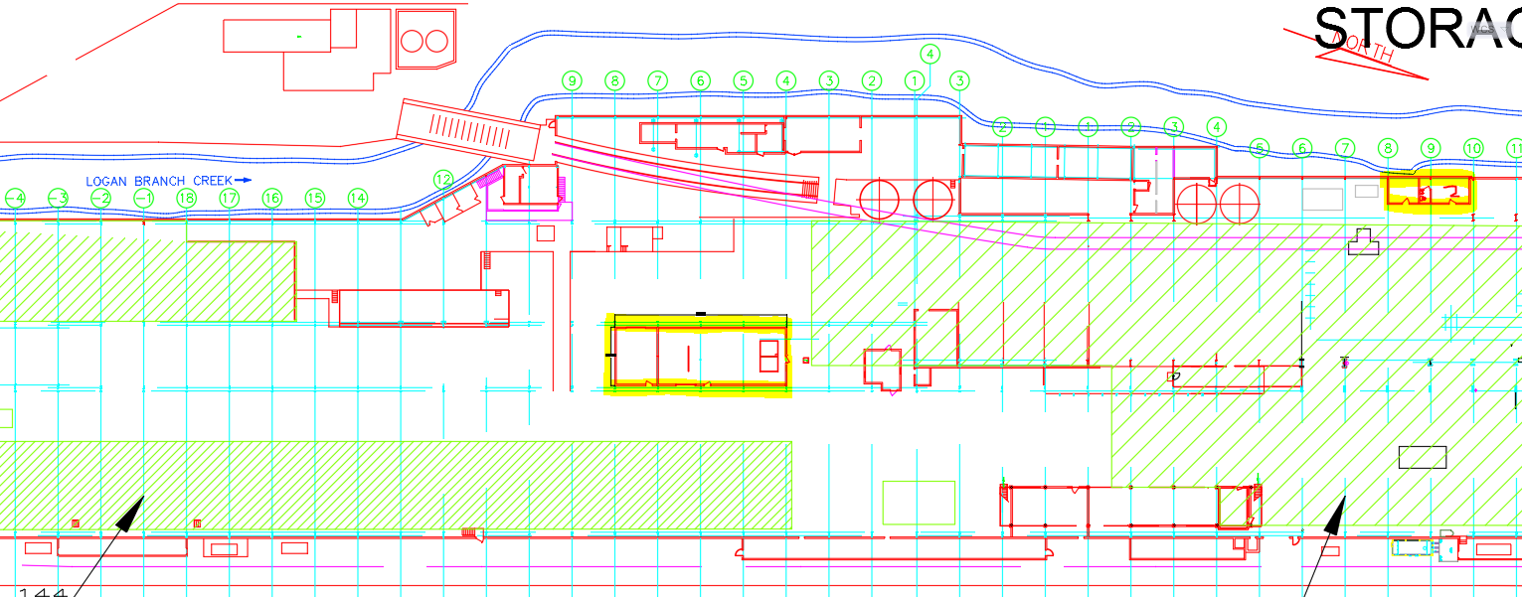

Plant 1 Carpentery shop:

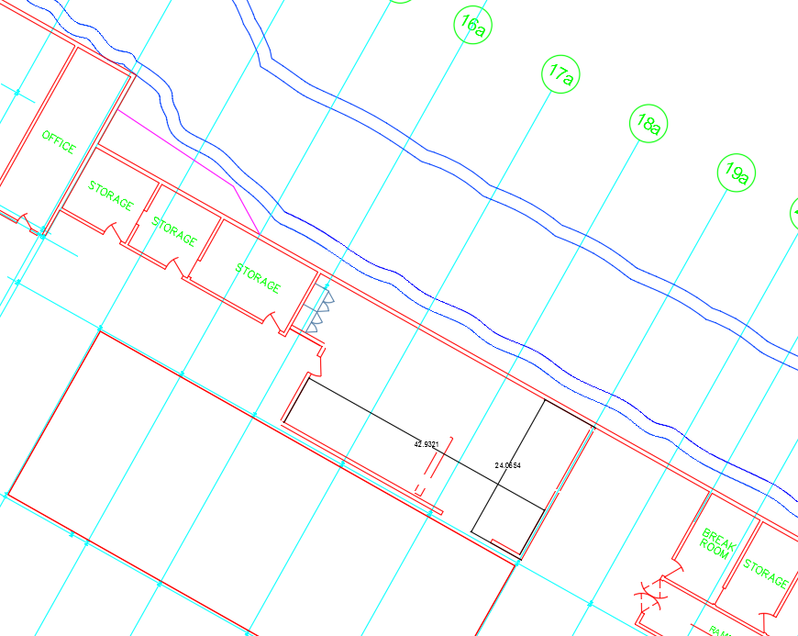

Plant 1 next to Winter cycle
